11/7/2022

**Online Food Order Management System**

Name: Kamaldeen Dilshad Hussian

Registration LMU ID: E026526



**Table of Contents**

Project Details 3

Background and Motivation 4

Problem in Brief 5

Aim 5

Objectives 6

Proposed Solution 6

Resource Requirements 9

Software Requirements 9

Hardware Requirements 9

Deliverables 9

Suggested Starting Point 9

Project Plan 10

# 

# **Project Details**

Title : Online Food Order Management System

Student Name : Kamaldeen Dilshad Hussain

Registration No : E026526

Supervisor : Ms. Sampa Withanachchi

Date Submitted : 2022-11-07

Date Approved :

**Introduction**

An online food ordering system is a web-based application that stimulates the foodies (customers) to put food orders through the internet by locating their favorite restaurant or nearest one. This application is based on the PHP platform.

It is known globally that, in today’s market, it is extremely difficult to start a new Small-scale business and live through the competition from well-established and settled owners. In the fast-paced time of today, when everyone is squeezed for time, the majority of people are exacting when it comes to placing a food order. The customers of today are not only attracted because placing an order online is very convenient but also because they have visibility into the items offered, price, and extremely simplified navigation for the order.

Manual listing of orders by the waiters/waitresses may result to slow response in customer service. Hence, if the restaurant uses this system, manipulation of orders from the customers be so easy and quick by just choosing the desired menu available in the system. The online ordering system here greatly simplifies the ordering process for both the customer and the restaurant. The system presents an interactive and up-to-date menu with all available options in the Customer to use process. Customers can choose items to place an order which will land in the Cart. Customers can view all the order details in the cart before checking out. In the end, the customer gets the order confirmation details. Once the order into placed it is entered into the database and retrieved in pretty much real-time. This allows Restaurant Employees to quickly go through the orders as they are received and process all orders efficiently and effectively with minimal delays and confusion

# **Background and Motivation**

The motivation for designing this application came because of major reasons Last year and still this covid19 pandemic, Monkey pox & Some personally do not like waiting for long in restaurants or having to call a restaurant to place an order especially when I am too hungry and also some people hesitate to ask detailed information of the menus like price and etc. even I don’t like and also it will help us to avoid the long queues at the counter and also in this covid19 situation & Monkey pox Situation.

# **Problem in Brief**

For placing any orders customers have to visit hotels or restaurants to know about food items and then place an order and pay, for that processing time and manual work is required and it’s very difficult because of the COVID19 & Monkey pox Pandemic Situation.

While placing an order over the phone, the customer lacks the physical copy of the menu item, lack of visual confirmation that the order was placed correctly. Every restaurant needs certain employees to take the order over the phone or in person, to offer a rich dining experience and process the payment. In today’s market, labor rates are increasing day by day making it difficult to find employees when needed. Hence, to solve this issue, the “Online Food Order System, is proposed and originally designed for small-scale businesses like cafes, Fast Food restaurants.

The system greatly simplifies the ordering process for both the customer and the restaurant and also greatly lightens the load on the restaurants. The system will also automatically calculate and displays the final bill so the bills will be ready to print without having any error because the information for that item will be already inserted.

# **Aim**

Its main aim is to simplify and improve the efficiency of the ordering process for both customer and restaurant, minimize manual data entry and ensure data accuracy and security during the order placement process. Customers will also be able to view product menus and their ingredients and be able to have a visual confirmation that the order was placed correctly. This software is developed to help computer science students to learn about applications to build a complete working application. The following givens are the aims of this project:

* Reduce time-consuming phone orders and eliminate illegible fax orders.
* No busier phones or the requirement for extra phone lines.
* An edge over the competition at a premium price.
* Broader customer reaches across regions.
* Builds a customer database.
* Provides a channel for marketing and promotion lowering your advertising cost.
* Greater customer satisfaction.

# **Objectives**

The objective of this project is to study how the online food ordering website works and the process of the system followed by the users.

* To develop an application that gives provisions the restaurant owners to develop their business by uploading menus at no cost which will invariably lead to higher customer retention and purchase rates.
* To ensure customer satisfaction.
* To increase efficiency and improve services provided to the customers through better application of technology.
* It is designed to increase efficiency, save money and time
* It shows the correct menu and enables the customers to order items that are available.
* To avoid long queues at the counter.
* To accommodate huge amounts of orders at a time.
* To improve the communication between the client and the server

# **Proposed Solution**

In this project, we decided to make a food-ordering website. Where there is an admin, who will provide the id and password to the restaurant, and then the restaurant contacts the admin and receives the id and password then the restaurant logs into the system they can start doing their job inserting the food items with the actual price. Here all the customers can visit the page and place an order. Customers can also set the time for delivery.

This system will be completely web-based and will be developed using PHP. We will have one home page where multiple options allow the user to choose different food items with the actual price. There will be a system administrator who will have the right to add and manage user accounts, and a manager who will be managing products and orders. Following is the system design of the system:

* Create an account.
* Manage their account.
* Log in to the system.
* Navigate the restaurant’s menu.
* Select an item from the menu.
* Add an item to their current order.
* Review their current order.
* Provide payment details.
* Place an order.
* Receive confirmation

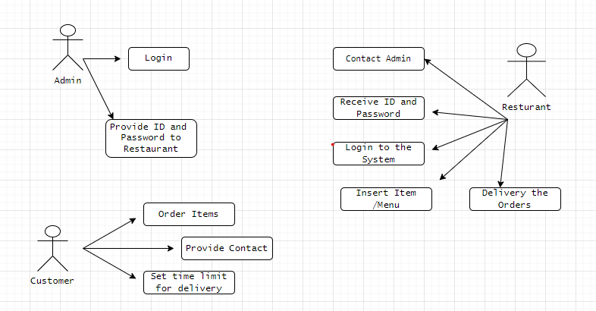

Figure 1 Use Case Diagram

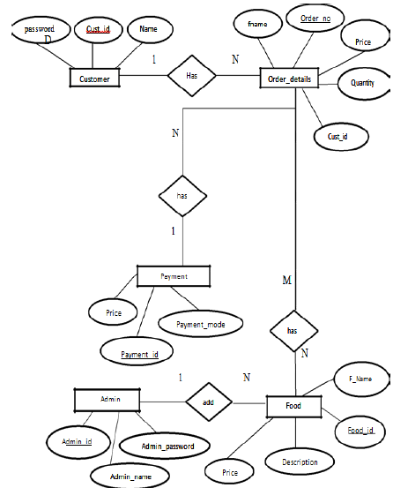

Figure 2 ER Diagram

# **Resource Requirements**

## **Software Requirements**

* Operating System: Windows 10 operating system.
* Database management system: MySQL (XAMPP).
* Code Editor: Visual Studio Code.
* Web Browser: Google Chrome.
* Reports: WPS Excel, MS office
* Coding Languages: PHP, HTML, CSS, JavaScript, and (Bootstrap 4 Framework).

## **Hardware Requirements**

* Laptop computer: with Intel core I3 processor CPU, 8 GB RAM, and 2TB Hard Disk.
* Router.

# **Deliverables**

The outcome of this project is to launch a fully functional Online Food Ordering Website.

# **Suggested Starting Point**

Requirement gathering - Getting permission for meeting with a client and discussing the requirements.

Design and analysis – It contains the design of the project. It includes various diagrams such as Use case, ERD, and class diagram. Gathering linked documents and designing a graphical solution for the system.

Development – This is the point of development of the web application, the PHP design is made.

Documentation –The recording of everything happening in the project.

# **Project Plan**

**Gantt chart**

|  |  |  |  |  |  |  |
| --- | --- | --- | --- | --- | --- | --- |
| Task | November | December | January | February | March | April |
| Preparation of the Project Proposal |  |  |  |  |  |  |
| Requirement gathering & analysis |  |  |  |  |  |  |
| Data Collection |  |  |  |  |  |  |
| Data Analysis |  |  |  |  |  |  |
| Report Writing |  |  |  |  |  |  |
| Preparation For the Project |  |  |  |  |  |  |

# **References**

 mack, j., 2022. *Free Online Ordering System for Restaurants.* [online] Gloriafood.com. Available at: <https://www.gloriafood.com/> [Accessed 25 Oct 2022].

En.wikipedia.org. 2022.*Online food ordering - Wikipedia.* [online] Available at: <https://en.wikipedia.org/wiki/Online_food_ordering> [Accessed 01 November 2022].

Pomelopay.com. 2022. *Online Ordering Systems: What Are The Advantages of Using One?.* [online] Available at: <https://www.pomelopay.com/blog/advantages-online-ordering-system> [Accessed 2 November 2022].

ProjectNotes. 2022. *Food Ordering System In Php With Source Code - ProjectNotes*. [online] Available at: <https://projectnotes.org/it-projects/food-ordering-system-in-php-with-source-code/> [Accessed 3 November 2022].